LAB Logbook

Lab 1

Lab 2

Lab 3

Lab 4

Lab 5

Lab 6

**Model: "sequential_1"**

┏━━━━━━━━━━━━━━━━━━━━━━━━━━━━━━━━━┳━━━━━━━━━━━━━━━━━━━━━━━━┳━━━━━━━━━━━━━━━┓

┃ **Layer (type)** ┃ **Output Shape** ┃ **Param #** ┃

┡━━━━━━━━━━━━━━━━━━━━━━━━━━━━━━━━━╇━━━━━━━━━━━━━━━━━━━━━━━━╇━━━━━━━━━━━━━━━┩

│ lstm (LSTM) │ (None, 130) │ 68,640 │

├─────────────────────────────────┼────────────────────────┼───────────────┤

│ dense_1 (Dense) │ (None, 1) │ 131 │

└─────────────────────────────────┴────────────────────────┴───────────────┘

**Total params:** 68,771 (268.64 KB)

**Trainable params:** 68,771 (268.64 KB)

**Non-trainable params:** 0 (0.00 B)

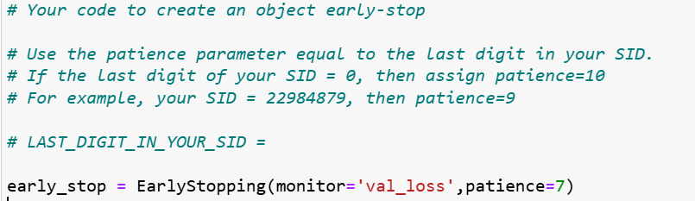

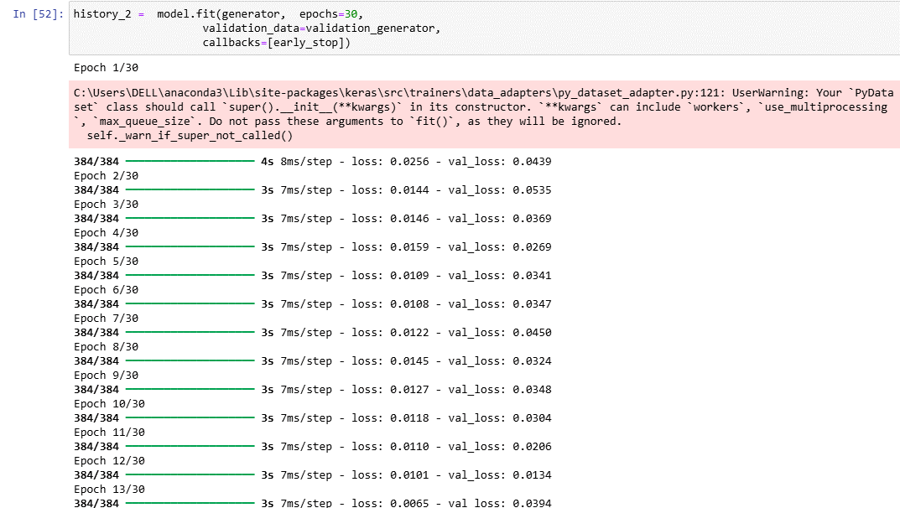

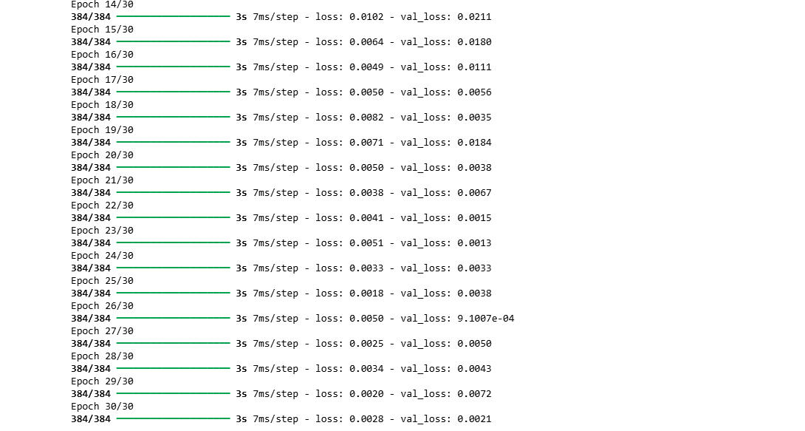

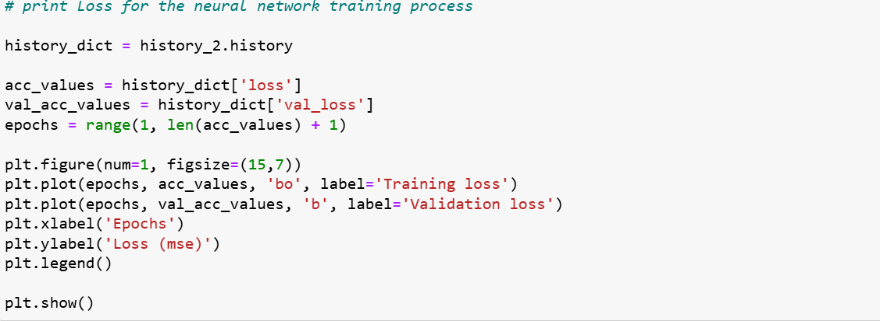

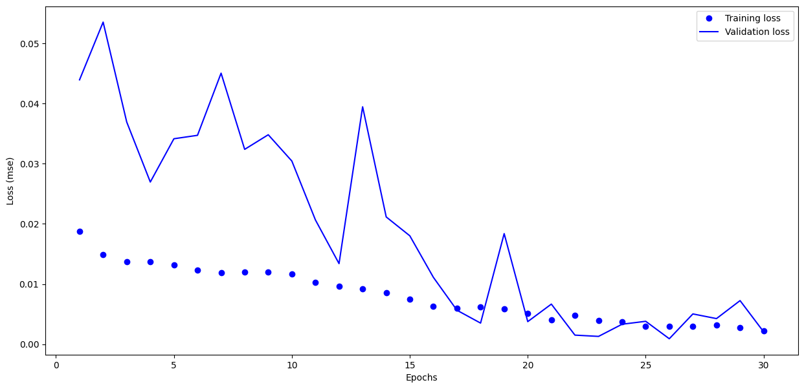

The optimal number of epochs for training my model is around 15-20 as it becomes unstable and spikes after around 17 epochs.

Lab 7

Lab 8

Lab 9

Lab 10

Lab 11

Lab 12